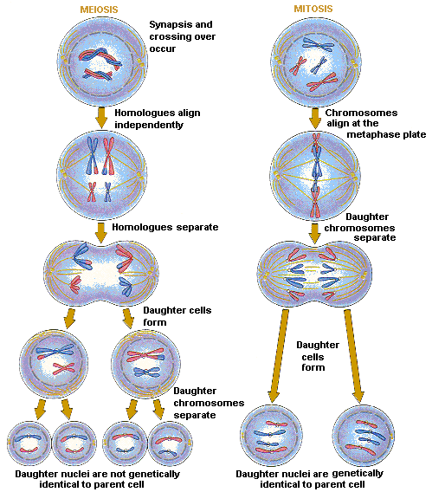
MEIOSIS vs MITOSIS

Questions:

1. Describe what is happening at the first stage of meiosis that is not happening at the first stage of mitosis. ______________________________________________________
________________________________________________________________________
________________________________________________________________________

2. In the third diagrams is there the same number of chromosomes in the cells? _____

3. How do the final cells vary in meiosis and mitosis? _________________________
________________________________________________________________________
________________________________________________________________________

4. How many cells do you end up with in meiosis? ________ and mitosis? ________

